1.) Document any additions/deletions/changes made to your Week #1 and/or #2 Deliverable Reports but do not submit any of these again.

**No changes**

2.) Domain Model of MVP/domain:

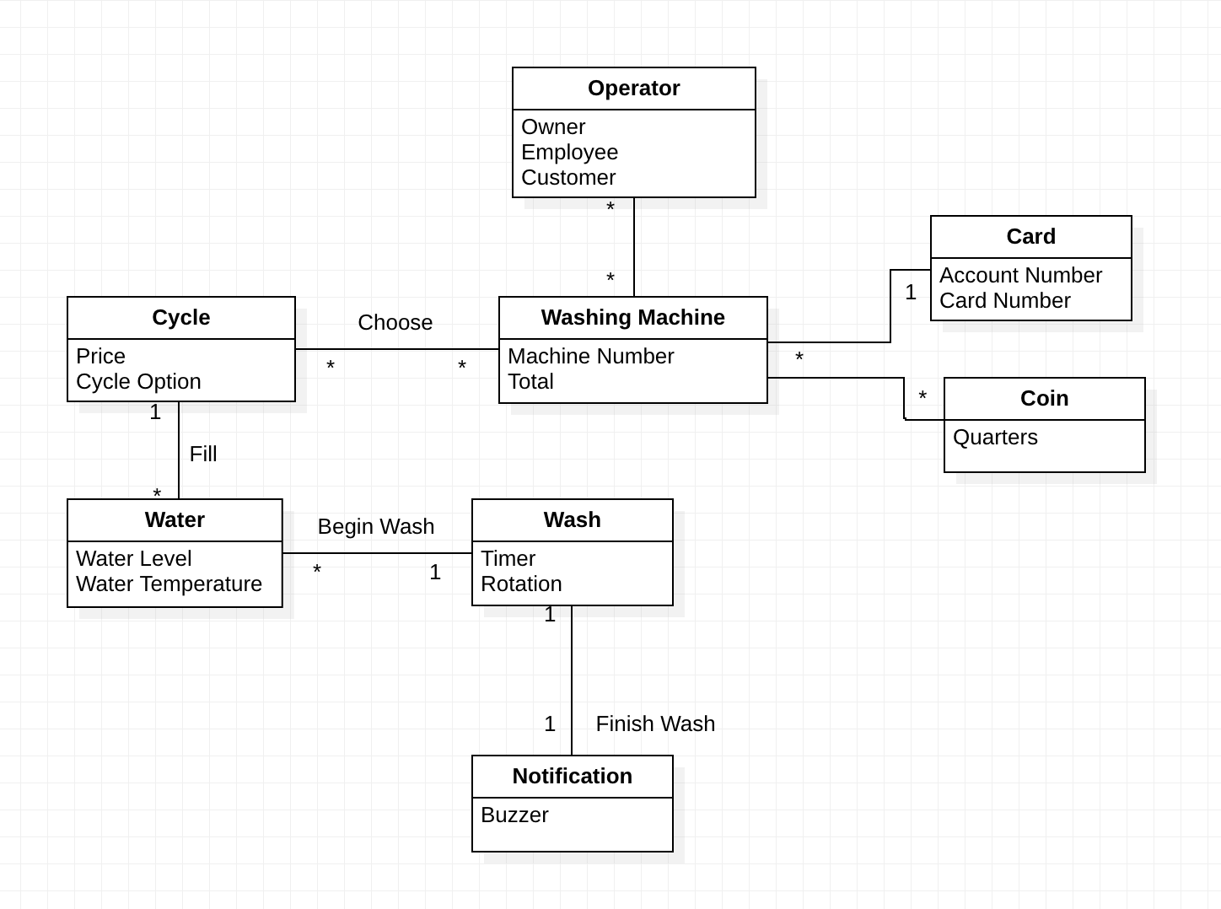

3.) UML Class Diagram:

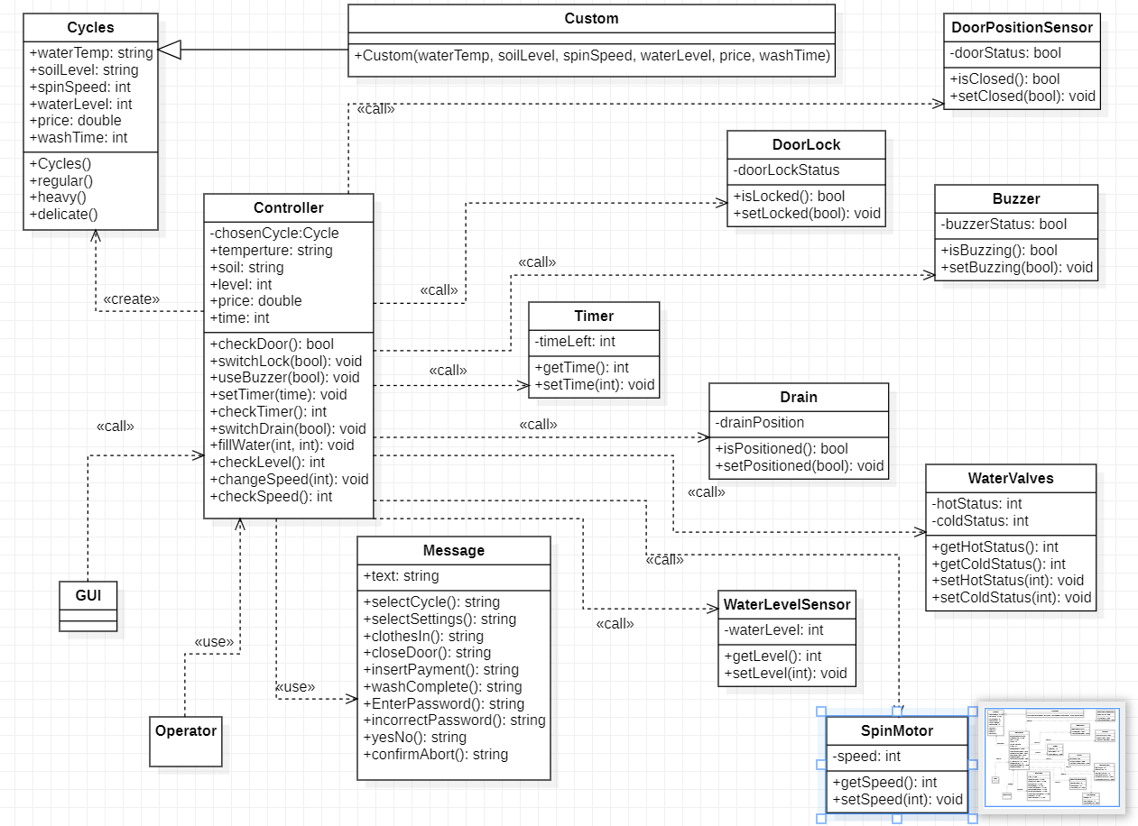

4.) Actor-System Interaction Model of top 3 Use Cases:

| **UC3 - Preprogrammed Cycles** | |
| --- | --- |
| Precondition: | |
| Actor: Customer | System: Washing Machine |
|  | 0. Machine displays message to select cycle |
| 1. TUCBW customer selects preprogrammed cycle option | 2. Machine displays “Confirm cycle” dialogue |
| 3. The customer:  a.) Confirms, or  b.) declines | 4. Machine accordingly displays  a.) “Insert clothes and pour detergent”, or  b.) TUCEW the machine displays transaction failed message |
| 5. The customer: a.) opens door within 5 minutes and inserts clothes and detergent  b.) does not open the door within 5 minutes | 6. Machine accordingly displays  a.) “Please close door”, or  b.) TUCEW the machine displays transaction fails message |
| 7. The customer:  a.) closes door within 5 minutes  b.) leaves door open for 5 minutes  c.) leaves door open for 10 minutes | 8. Machine  a.) displays confirming door closed, or  b.) beeps once, or  c.) TUCEW Machine beeps continuously |
| 9. TUCCW one of the following use cases: a.) UC1 Card Payments  b.) UC2 Coin Payments |  |
| Postcondition: | |

| **UC2 - Coin Payment** | |
| --- | --- |
| Precondition: The customer must have already selected their cycle and inserted their clothes and detergent | |
| Actor: Customer | System: Washing Machine |
|  | 0. Machine displays pricing of cycle and “Please insert payment” |
| 1. The customer  a.) inserts coins into the machine, or  b.) pushes coin release lever | 2. Machine  a.) deducts inserted coin amount from cycle price, and when coins inserted is equal to cycle price, displays the message, “Press start”, or  b.) TUCEW the machine returning coins to customer and displays transaction failed message |
| 3. The customer  a.) Presses the start button within 5 minutes, or  b.) does not press the start button within the given time | 4. The machine  a.) confirms the door is closed and locks it before it begins its wash cycle  b.) continues to beep if door is closed, locks it, then starts its cycle |
| 5. The customer finishes washing their clothes | 6. Machine displays the message, “Cycle finished, please remove clothes”. |
| 7. TUCEW the customer takes their clothes |  |
| Postcondition: | |

| **UC7 - Abort Wash Cycle** | |
| --- | --- |
| Precondition: The customer must have already started the wash cycle | |
| Actor: Employee | System: Washing Machine |
| 1. The employee presses the abort wash button | 2. Machine displays, “Please enter the pin” |
| 3. The employee enters their pin | 4. Machine displays, “Authorizing Pin”. If authorization is successful, machine will display, “Abort Cycle?”. If pin authorization is not successful, TUCEW the employee gets one more chance to enter the pin and they enter the incorrect pin a second time and the machine displays, “Abort Cycle failed” then returns back to cycle. |
| 5. The employee  a.) Selects yes, or  b.) Selects no | 6. If the employee selects yes, TUCEW the machine stops the cycle, opens the drain and unlocks the door. Otherwise, TUCEW the machine returns back to cycle. |
| Postcondition: | |

5.) Sequence Diagram and narrative – See separate PDF attachment for diagram.

Narrative:

User selects a cycle option which sends the information to the controller. The controller initiates the message: “Please select cycle”.

If the user selects a preprogrammed cycle, the information for the preprogrammed cycle is sent to the controller. The washing machine then displays the message “insert clothes”.

If the user selects custom cycle, the washing machine displays the message “Choose settings”. User selects the settings (water temperature, spin speed, soil intensity, etc.), which sends the information to the controller. The selected settings are set for the custom cycle and the information is sent to the controller. The washing machine then displays the message “insert clothes”.

If the cycle is selected, the controller determines whether the door of the washer has been opened for the user to insert clothes.

If the door has been opened within 5 minutes of selecting the cycle, the machine will display the message “close door”, to prompt the user to close the door after loading their laundry and detergent.

If the door has not been within 5 minutes of selecting the cycle, the machine will reset to the choose cycle function and the machine will display the message “transaction failed”.

If the door of the washing machine is closed it will proceed to determine if the door of the washing machine is locked.

If the door is locked, the machine will display the message “Proceed to payment”.

If the door is not locked, the user is given 5 minutes to allow the door to lock before hearing an audible beep. If the door does not lock after 10 minutes, the cycle is canceled and the machine displays the message “Beep!!! Transaction canceled”.

If the door of the washing machine is locked, the machine will display the message “Select payment”, prompting the user to choose a payment option.

If the user selects the coin payment option, the machine will generate a loop.

If the coin release is pressed the machine will return the coins to the user, the transaction will be canceled, and the machine will display the message “Transaction canceled, collect coins below”.

If the coin release is not pressed, the machine continues the loop until the value of the coins entered is equal to the price of the selected cycle. When the correct amount of coins is entered.

If the user selects the card payment option, the machine sends the information to the controller.

If the card is a credit card, the machine will display the message “Enter zipcode”. The user enters the zipcode, the controller tells the machine to display the message “Authorizing payment” and sends the zipcode information to the CardAuth object.

If the card is a debit card, the machine will display the message “Enter pin”. The user enters the pin, the controller tells the machine to display the message “Authorizing payment” and sends the pin information to the CardAuth object.

If the payment is authorized, the machine displays the message “Press start”. The user presses the start button and the controller sends the message to start the cycle. The machine then displays the message “Cycle started”.

When the cycle is finished, the machine displays the message “Cycle finished, please remove clothes”.

If the abort cycle button is pressed at any time during the cycle, the controller sends to abort the cycle and the machine prompts the employee (user) to enter their pin.

If the correct pin is entered, the controller sends the information to confirm the abort cycle operation and the machine displays the message “cycle aborted”.

If an incorrect pin is entered, the machine displays the message “Abort cycle canceled”.